*Provided by:  
1. Ahmad Muhaimin Azeem (B122310496, 2 BERR S2)*

*2 Syafiq Iman bin Suhaimi ( B122310218, 2 BERR S2)*

Exercise Questions

Answer these by completing the lab steps and observing results.

1. Code Execution & Output

o After running your index.js script:

* What exact text does the console display when the document is inserted?

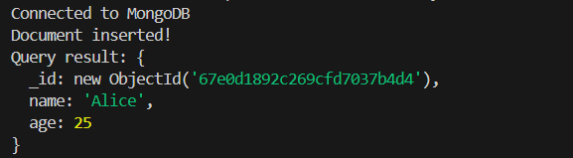

* What _id value is automatically assigned to the document?



2. Modify and Observe

o Change the name field in index.js to your own name and the age to your birth year. Run the script again.

* What new _id is generated for this document?

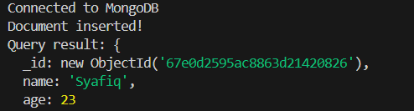

* What error occurs if you forget to call await client.connect()?

No error

3. MongoDB Connection Failure

o Intentionally break the MongoDB connection string (e.g., change the port to 27018).

* What error message does NodeJS throw?

Connected to MongoDB

Error: MongoServerSelectionError: connect ECONNREFUSED ::1:27018, connect ECONNREFUSED 127.0.0.1:27018

at Topology.selectServer (C:\Users\James\Desktop\SEMESTER 4\Database System and Cloud BERR2243 DR SOO YEW GUAN\Exercises\Week 1 Exercise 1 v2\node_modules\mongodb\lib\sdam\topology.js:321:38)

at async Topology._connect (C:\Users\James\Desktop\SEMESTER 4\Database System and Cloud BERR2243 DR SOO YEW GUAN\Exercises\Week 1 Exercise 1 v2\node_modules\mongodb\lib\sdam\topology.js:200:28)

at async Topology.connect (C:\Users\James\Desktop\SEMESTER 4\Database System and Cloud BERR2243 DR SOO YEW GUAN\Exercises\Week 1 Exercise 1 v2\node_modules\mongodb\lib\sdam\topology.js:152:13)

at async topologyConnect (C:\Users\James\Desktop\SEMESTER 4\Database System and Cloud BERR2243 DR SOO YEW GUAN\Exercises\Week 1 Exercise 1 v2\node_modules\mongodb\lib\mongo_client.js:233:17)

at async MongoClient._connect (C:\Users\James\Desktop\SEMESTER 4\Database System and Cloud BERR2243 DR SOO YEW GUAN\Exercises\Week 1 Exercise 1 v2\node_modules\mongodb\lib\mongo_client.js:246:13)

at async MongoClient.connect (C:\Users\James\Desktop\SEMESTER 4\Database System and Cloud BERR2243 DR SOO YEW GUAN\Exercises\Week 1 Exercise 1 v2\node_modules\mongodb\lib\mongo_client.js:171:13)

at async autoConnect (C:\Users\James\Desktop\SEMESTER 4\Database System and Cloud BERR2243 DR SOO YEW GUAN\Exercises\Week 1 Exercise 1 v2\node_modules\mongodb\lib\operations\execute_operation.js:99:13)

at async abortable (C:\Users\James\Desktop\SEMESTER 4\Database System and Cloud BERR2243 DR SOO YEW GUAN\Exercises\Week 1 Exercise 1 v2\node_modules\mongodb\lib\utils.js:1181:16)

at async executeOperation (C:\Users\James\Desktop\SEMESTER 4\Database System and Cloud BERR2243 DR SOO YEW GUAN\Exercises\Week 1 Exercise 1 v2\node_modules\mongodb\lib\operations\execute_operation.js:38:11)

at async Collection.insertOne (C:\Users\James\Desktop\SEMESTER 4\Database System and Cloud BERR2243 DR SOO YEW GUAN\Exercises\Week 1 Exercise 1 v2\node_modules\mongodb\lib\collection.js:157:16) {

errorLabelSet: Set(0) {},

reason: TopologyDescription {

type: 'Unknown',

servers: Map(1) { 'localhost:27018' => [ServerDescription] },

stale: false,

compatible: true,

heartbeatFrequencyMS: 10000,

localThresholdMS: 15,

setName: null,

maxElectionId: null,

maxSetVersion: null,

commonWireVersion: 0,

logicalSessionTimeoutMinutes: null

},

code: undefined,

[cause]: MongoNetworkError: connect ECONNREFUSED ::1:27018, connect ECONNREFUSED 127.0.0.1:27018

at Socket.<anonymous> (C:\Users\James\Desktop\SEMESTER 4\Database System and Cloud BERR2243 DR SOO YEW GUAN\Exercises\Week 1 Exercise 1 v2\node_modules\mongodb\lib\cmap\connect.js:285:44)

at Object.onceWrapper (node:events:633:26)

at Socket.emit (node:events:518:28)

at emitErrorNT (node:internal/streams/destroy:170:8)

at emitErrorCloseNT (node:internal/streams/destroy:129:3)

at process.processTicksAndRejections (node:internal/process/task_queues:90:21) {

errorLabelSet: Set(1) { 'ResetPool' },

beforeHandshake: false,

[cause]: AggregateError [ECONNREFUSED]:

at internalConnectMultiple (node:net:1139:18)

at afterConnectMultiple (node:net:1712:7) {

code: 'ECONNREFUSED',

[errors]: [Array]

}

}

}

PS C:\Users\James\Desktop\SEMESTER 4\Database System and Cloud BERR2243 DR SOO YEW GUAN\Exercises\Week 1 Exercise 1 v2> ^C

PS C:\Users\James\Desktop\SEMESTER 4\Database System and Cloud BERR2243 DR SOO YEW GUAN\Exercises\Week 1 Exercise 1 v2> node index.js

Connected to MongoDB

Error: MongoServerSelectionError: connect ECONNREFUSED ::1:27018, connect ECONNREFUSED 127.0.0.1:27018

at Topology.selectServer (C:\Users\James\Desktop\SEMESTER 4\Database System and Cloud BERR2243 DR SOO YEW GUAN\Exercises\Week 1 Exercise 1 v2\node_modules\mongodb\lib\sdam\topology.js:321:38)

at async Topology._connect (C:\Users\James\Desktop\SEMESTER 4\Database System and Cloud BERR2243 DR SOO YEW GUAN\Exercises\Week 1 Exercise 1 v2\node_modules\mongodb\lib\sdam\topology.js:200:28)

at async Topology.connect (C:\Users\James\Desktop\SEMESTER 4\Database System and Cloud BERR2243 DR SOO YEW GUAN\Exercises\Week 1 Exercise 1 v2\node_modules\mongodb\lib\sdam\topology.js:152:13)

at async topologyConnect (C:\Users\James\Desktop\SEMESTER 4\Database System and Cloud BERR2243 DR SOO YEW GUAN\Exercises\Week 1 Exercise 1 v2\node_modules\mongodb\lib\mongo_client.js:233:17)

erations\execute_operation.js:99:13)

at async abortable (C:\Users\James\Desktop\SEMESTER 4\Database System and Cloud BERR2243 DR SOO YEW GUAN\Exercises\Week 1 Exercise 1 v2\node_modules\mongodb\lib\utils.js:1181:16)

at async executeOperation (C:\Users\James\Desktop\SEMESTER 4\Database System and Cloud BERR2243 DR SOO YEW GUAN\Exercises\Week 1 Exercise 1 v2\node_modules\mongodb\lib\operations\execute_operation.js:38:11)

at async Collection.insertOne (C:\Users\James\Desktop\SEMESTER 4\Database System and Cloud BERR2243 DR SOO YEW GUAN\Exercises\Week 1 Exercise 1 v2\node_modules\mongodb\lib\collection.js:157:16) {

errorLabelSet: Set(0) {},

reason: TopologyDescription {

type: 'Unknown',

servers: Map(1) { 'localhost:27018' => [ServerDescription] },

stale: false,

compatible: true,

heartbeatFrequencyMS: 10000,

localThresholdMS: 15,

setName: null,

maxElectionId: null,

maxSetVersion: null,

commonWireVersion: 0,

logicalSessionTimeoutMinutes: null

},

code: undefined,

[cause]: MongoNetworkError: connect ECONNREFUSED ::1:27018, connect ECONNREFUSED 127.0.0.1:27018

at Socket.<anonymous> (C:\Users\James\Desktop\SEMESTER 4\Database System and Cloud BERR2243 DR SOO YEW GUAN\Exercises\Week 1 Exercise 1 v2\node_modules\mongodb\lib\cmap\connect.js:285:44)

at Object.onceWrapper (node:events:633:26)

at Socket.emit (node:events:518:28)

at emitErrorNT (node:internal/streams/destroy:170:8)

at emitErrorCloseNT (node:internal/streams/destroy:129:3)

at process.processTicksAndRejections (node:internal/process/task_queues:90:21) {

errorLabelSet: Set(1) { 'ResetPool' },

beforeHandshake: false,

[cause]: AggregateError [ECONNREFUSED]:

at internalConnectMultiple (node:net:1139:18)

at afterConnectMultiple (node:net:1712:7) {

code: 'ECONNREFUSED',

[errors]: [Array]

}

}

}

* What is the exact text of the error code (e.g., ECONNREFUSED)?



4. MongoDB Shell Query

o Use the MongoDB shell (not Compass) to:

* List all documents in the testDB.users collection.

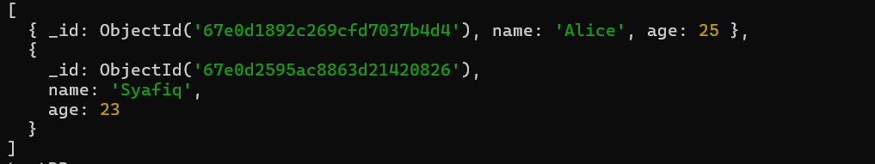

* What command did you use? Paste the full output.

use testDB

db.users.find()

5. File System & Dependencies

o What is the absolute path to your project’s package-lock.json file?

C:\Users\James\Desktop\SEMESTER 4\Database System and Cloud BERR2243 DR SOO YEW GUAN\Repository\Gemini-Man

o What exact version of the mongodb driver is installed?

By running the following code, npm list mongodb, at VS Code, the exact version of installed mongodb driver is [mongodb@6.15.0](mailto:mongodb@6.15.0)



6. Troubleshooting Practice

o Stop the MongoDB service and run the script.

* What error occurs?

Same error like Question 3

* What command restarts the service?

Net start MongoDB

7. GitHub Repository Structure

o On GitHub, navigate to your repository’s.

* What timestamp is listed for your last commit?

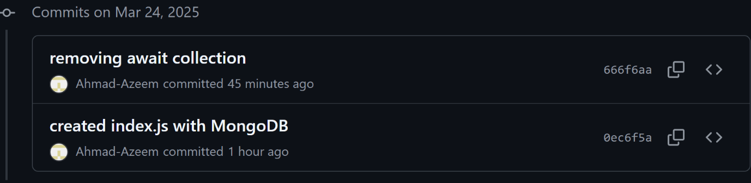

* How many files are present in this branch?

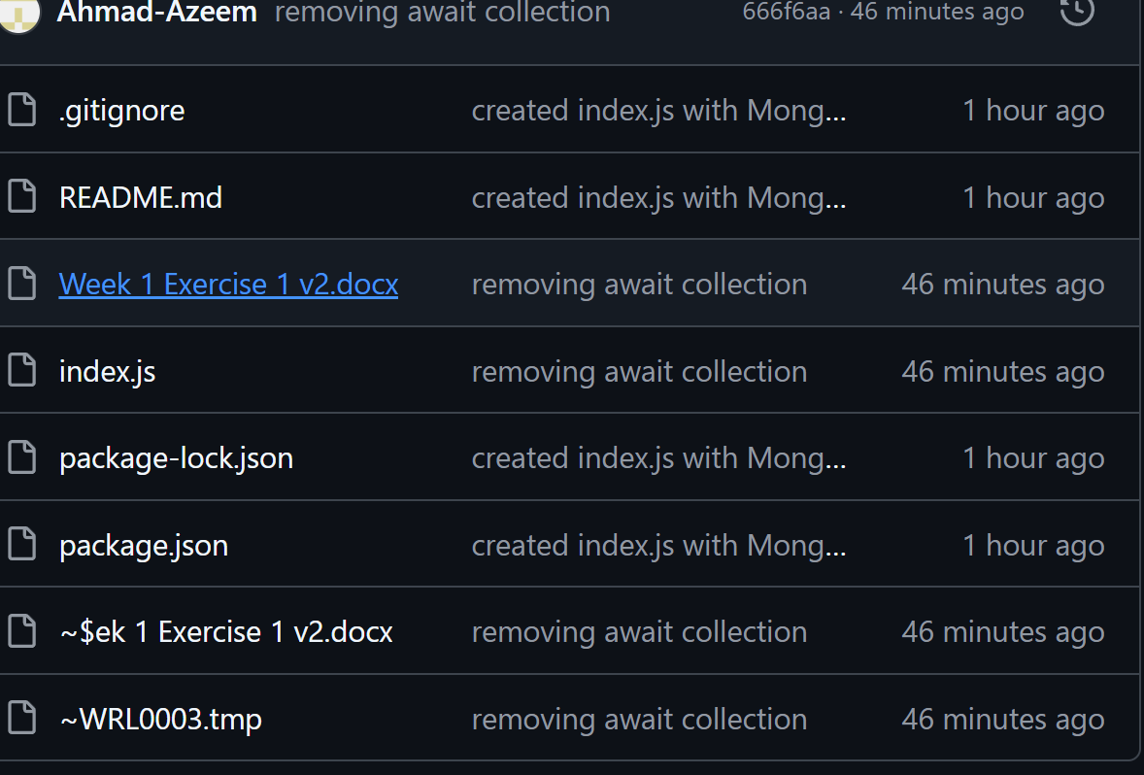

Six files are present

8. Performance Observation

o Time how long it takes for the script to print "Connected to MongoDB!".

* What is the duration (in milliseconds)?

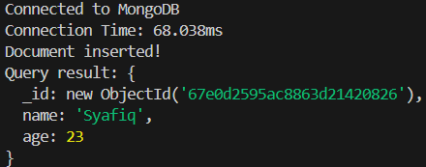

Answer: 68.03 ms

* Does this time change if you run the script again? Why?

Yes because of the various factors such as server load, network conditions and whether the server is already warmed up. Even small changes in these factors can influence the duration of the connection.

1. GitHub repository:

<https://github.com/Ahmad-Azeem/min-iman>

1. Screenshots:
2. Successful MongoDB connection in Node.js

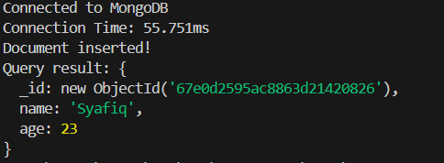

1. The document in MongoDB Compass

